Oil Pressure Gauge – CGEA1.3

Functional Description

The purpose of the Oil Pressure Gauge is to inform the driver of an unsafe engine operating condition due to low engine oil pressure.

The Oil Pressure Gauge Function correlates the Low Oil Pressure Switch status and Operational_Mode to generate a pointer position on the Oil Pressure Gauge.

The Oil Pressure Switch input to the Instrument Cluster shall be received either via hardwired A/D input or via CAN signal. The Instrument cluster shall be configured for either input. Either input may be available on any given cluster program, but only one input will be on any single vehicle.

For certain applications the entire gauge or a portion of the gauge turns red to enhance indication of a warning condition (specifics as per HMI). The Low_Oil_Pressure_MC_Status_Flag which is controlled per the Low Oil Pressure RTT, Fixed Telltale, & Warning section is used to control this function. Use of the the Low_Oil_Pressure_MC_Status_Flag insures the telltale/RTT will activate at the same time the gauge turns red and this saves duplicating the more complex Telltale/RTT logic in this section. This generally applies to a virtual gauge but this could be applied to hard gauge (MyColor is one example).

Interfaces

Interface Context Diagram (I/O Block Diagram)
Figure 1 Oil Pressure Gauge Context Diagram 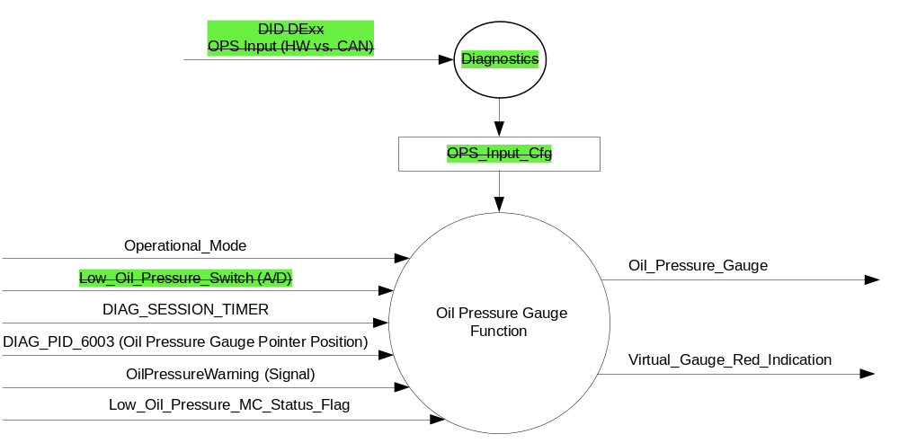

Inputs

- INTERNAL:
    - Low_Oil_Pressure_MC_Status_Flag (set inactive/active as per Low Oil Pressure RTT, Fixed Telltale, & Warning section)
    - DIAG_SESSION_TIMER
    - Diagnostic DID 6003 (Oil Pressure Gauge Pointer Position)
    - Operational_Mode
    - OPS_Input_Cfg
- The Oil Pressure Switch input, which per OPS_Input_Cfg shall be either
- Low_Oil_Pressure_Switch (A/D), hardwired to the cluster
Or
- OilPressureWarning, MUX message on the CAN Bus
- Input Description for Hardwired Low_Oil_Pressure_Switch (A/D)
Oil Pressure | Oil Pressure Switch State | Oil Pressure Switch Reading | Debounce | Low_Oil_Pressure_Switch  (A/D)
Less than Trip Point | Open | > 1000 ohms to Open circuit | Min 5 samples in a row @ 6-10 ms | > OPS_Trip_Point
Greater than Trip Point | Closed | 1000 ohms to 0 Ohms, inclusive | Min 5 samples in a row @ 6-10 ms | < = OPS_Trip_Point
            - Normally Open Oil Pressure Switch has its contact open when “sitting on the shelf."
            - The highest ohm value (1000 ohm) for the Closed State of the Oil Pressure Switch must result in a Low_Oil_Pressure_Switch <= OPS_Trip_Point for all voltage inputs across the production build. Therefore, the lowest ohm value for the Open State of the Oil Pressure Switch that will result in a Low_Oil_Pressure_Switch > OPS_Trip_Point will vary across the production build. This value must be lower than 1500 ohms across the production build.

- OilPressureWarning Signal
Signal Name | ID | Size  (bits) | Pos.  (bit) | Detail | Units | Res. | Offset | State  Encoded | Min. | Max.
OilPressureWarning | 0x420 | 1 | 21 |  | SED | 1 | 0 |  | 0 (0x0) | 1 (0x1)
 |  |  |  | Normal_Pressure_  Lamp_Off |  |  |  | 0x0
 |  |  |  | Low_Pressure_  Lamp_On |  |  |  | 0x1

- Input Arbitration
OPS_Input_Cfg | Debounced Low_Oil_Pressure_Switch  (A/D) | OilPressureWarning  (Signal) | Oil_Pressure_State  (internal variable)
0x0 (HW) | > OPS_Trip_Point | X | 0x1 (Low)
0x0 (HW) | < = OPS_Trip_Point | X | 0x0 (OK)
0x1 (HS_CAN) | X | 0x0 (OK) | 0x0 (OK)
0x1 (HS_CAN) | X | 0x1 (Low) | 0x1 (Low)
0x1 (HS_CAN) | X | Declared missing | 0x1 (Low)
All Other Cases |  |  | 0x1 (Low)

Outputs
- Oil Pressure Gauge Indication as per Oil_Pressure_Gauge flag
- Virtual_Gauge_Red_Indication

Function/Performance

Operational Modes

Mode | Differentiating Vehicle Conditions
Sleep Mode | Oil Pressure Gauge needle at “Rest Position”
Limited Mode | Oil Pressure Gauge needle at “Rest Position”
Normal Mode | Oil Pressure Gauge needle at “Oil Pressure Gauge” indication
Crank Mode | Oil Pressure Gauge needle at "Oil Pressure Gauge" indication or last “Oil Pressure Gauge” indication determined in Normal Mode.

Voltage Levels

Refer to Cluster Features table located in Master SPSS.

Human-Machine Interface

Visual

Indicator Graphics / Display Format
Figure 2 Oil Pressure Gauge Indication
Low
Normal
High

A
B
J
C
I
H
G
F
E
D

Gauge Position |  | Description
A |  | Low Stop
B |  | 2° below center of low
C |  | Center of low
D |  | 2° above center of low
E |  | Starting edge of norm band
F |  | Flat Zone
G |  | Ending edge of normal band
H |  | 2° below center high
I |  | Center of high
J |  | 2° above center of high

- The "High" graduation mark shall be on the right side of the indicating field, except when using a vertically arranged field, in which case the "High" graduation shall be on the top of the field.
- If red is used in the graphics, it can only be used for the "L" Grad.

Indicator Color Coordinates

- Reference section COLOR & ILLUMINATION REQUIREMENTS (GRAPHICS)
- It is recommended that the "Low" graduation mark be colored red.
- The "High" graduation may be the same as the normal band and/or text color.

Indicator Characteristics

Description of Gauge | Scale Range | Scale Span | Operating Span
North American | “L” to “H” | 0 – 86 angular degrees | -4 to 89

Audio

None

Switch Control Logic

None

System Accuracy

- Shall indicate within 100msec the data contained in Oil_Pressure_Gauge

Operation: Performance and Functional

Subsystem Algorithm Flowchart / State Diagram

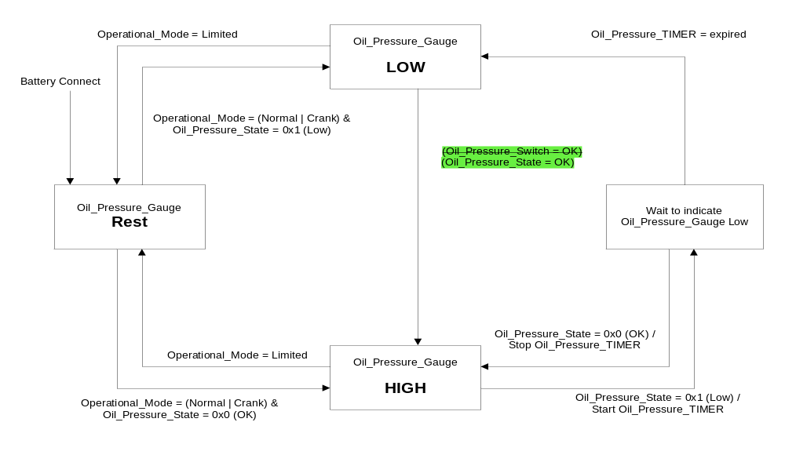

Operation Description (supports algorithm flowchart /state diagram)

- State Matrix for Oil Pressure Gauge
Operational_Mode | DIAG_SESSION  _TIMER | DIAG_DID_  6003  (Oil Pressure Gauge Pointer Position) | Oil_Pressure_Gauge
Normal or Crank | Not Active | X | As per Figure 2 - Oil Pressure Gauge  State Transition Diagram
Normal | Active | Not Received | As per Figure 2 - Oil Pressure Gauge  State Transition Diagram
Normal | Active | Received with Appropriated Data | Pointer Location per Diagnostic DID
All Other Cases |  |  | As per Figure 2 - Oil Pressure Gauge  State Transition Diagram

- Gauge Pointer Position Definition
Oil_Pressure_Gauge | Gauge Pointer (angular degrees) |  |  |  | Indication
Oil_Pressure_Gauge | Target | Min | Max | Tolerance Range
REST | -4.0 | -8.0 | 0 | 8.0 | Position A
LOW | 0.0 | -4.0 | 4.0 | 8.0 | Position C
HIGH | 50.0 | 48.0 | 52.0 | 4.0 | Position F
- Digital switch inputs shall be debounced with a minimum of 5 consecutive samples over period between 40ms to 50 ms. All samples must be identical in order to assert a new debounced value.
- When Oil_Pressure_State is OK while Ignition is RUN or START, start a 3.5 ± .35 second timer when it transitions from OK to LOW
  - Set Oil_Pressure_Gauge to LOW if Oil_Pressure_Switch remains LOW for the duration of the 3.5s timer
- When Oil_Pressure_Gauge is LOW while Ignition is RUN or START and the Oil_Pressure_State transitions from LOW to OK, set the Oil_Pressure_Gauge to OK.
- Typical maximum output delay = 73 msec: 50 msec to debounce input, 20 msec to process it and 3 msec to indicate switch status.

- Virtual_Gauge_Red_Indication
Operational Mode | Low_Oil_Pressure_MC_Status_Flag | Virtual_Gauge_Red_Indication
Normal or Crank | Active | On
All Other Cases |  | Off
- When Virtual_Gauge_Red_Indication = On the Virtual Gauge or a portion of a gauge shall turn red to help convey the warning condition as defined by HMI. Virtual_Gauge_Red_Indication is usually used for virtual gauge applications but could be used for a hard gauge and MyColor would be an example of that.

Function Safety Classification (EMC)

B

Memory Storage

Parameter Name | Description | Value at Battery Connect | Value at Module Wake-up
OPS_Input_Cfg | State Indicator defining input for Oil Pressure Switch information. Configured via CAN at VO EOL. Defaulted to 0 (HW) at cluster manufacturing location.  (0x0) = HW, (0x1) = HSCAN  For P473, always 0x1. | Use Stored Value | Use Stored Value
Low_Oil_Pressure_Switch (A/D) | Controlled by the value of the switch trip point | Closed (0x0) | Closed (0x0)
OilPressureWarning (HS_CAN) | Oil Pressure Switch Input | 0x1 (LOW) | 0x1 (LOW)
Low_Oil_Pressure_MC  _Status_Flag | Used to control the state of the warning message and virtual gauge color. | Inactive (0x0) | Inactive (0x0)
Oil_Pressure_State | Internal cluster variable used to correlate input config, HW and CAN OPS inputs into an arbitrated variable | 0x1 (LOW) | 0x1 (LOW)
Oil_Pressure_Gauge | Oil pressure gauge state which is derived from the oil pressure switch state | 0 (LOW) | 0 (LOW)
Virtual_Gauge_Red_Indication | Internal cluster variable used to turn the gauge or some portion of the gauge red. | Inactive (0x0) | Inactive (0x0)
DIAG DID 6003 | Oil Pressure Gauge Pointer Placement | 0 (0x0) | 0 (0x0)
Operational_Mode | 4 state indicator for cluster operational mode | Limited | Limited or Normal or Crank

Timer Name | Description | Value at Battery Connect | Value at Module Wake-up
Oil_Pressure_TIMER | 3.5 second timer used as a filter in determining low oil pressure | 0 | 0
DIAG_SESSION_TIMER | Timer used to time-out a diagnostic session | 0 | 0

Prove Out

No

Error Handling

- A short to GND will result in an acceptable oil pressure indication
- Broken wires, unconnected connectors or an open circuit will result in low oil pressure indication

Missing Message Strategy

The signals will be declared missing as per the Diagnostics section of this SPSS.

DTCs states and history will be determined as per the Diagnostics section of this SPSS.

If OPS_Input_cfg is configured as a hardwired A/D input, the cluster shall never log a missing message DTC due to this feature.

Diagnostics

Self Test

None

Engineering Test Mode

Reference section “Dealer / Engineering Test Mode (ETM)”

Part II Performance

Reference Part II Diagnostic Specification
DID DE00
Block  Num | Block Description | Byte(s) | Bits | State: Description | "0" | "1" | Default | Comments/Information
PACKETED BLOCKS
$00 | Option Content (B&A) |  | * | OPS_Input_Cfg | HW | HS_CAN | HW
 | *Byte and bit location to be identified in Part II Specification for this cluster

Supported Diagnostic DIDs (Service $22 and $2F)
Number | DID / CommonID Name | DID Type
6003 | Oil Pressure Gauge Pointer Placement | Numeric

Supported Diagnostic Trouble Codes (DTCs)

DTCs shall be logged as per the diagnostic section of this SPSS.

DTC | Description
C10000 | Lost Communication With ECM/PCM

Reference Specification

- Func. Criticality EC-0048
- Mod. PWR-up / Reset EC-0049
- Low-High Vol. Perform. EC-0058
- Jump Start EC-0062
- Instr. & Gauges (indic. Grad) IS-0015
- Gauge Durab. IS-0033
- Oper. Voltage Functional/Perf. IS-0052
- Sys. Audible Noise IS-0103
- Pointer Waver IS-0108
- Instr. Scale Dir. IS-0127
- Pointer Position IS-0128
- Signal Logic: Communization IS-0129
- Sensor Packaging IS-0131
- Electrical IS-0132
- Oil Pressure Gauge IS-0316
- Vibration - Gauge Perf. IS-0326
- Temp. Warn. IS-0342
- Symbol Usage 01-0238 / 01-0239
- Symbol Leg. 01-0240
- Placement - Parts Loc. 03-0001
- Glare/Reflections 16-0068
- Reflection 17-0018
- Robust Sound Quality 17-0032
- Harmony: Graphics / Font / Ill. 17-0040
- Placement Vis. ID 17-0051
- Ergo - Access. 17-0052
- Ergo - Operability 17-0053
- Control & Display Loc. 17-0060
- Logical grouping Function and Usage 17-0062
- Assoc. of Controls with Disp. & elem. 17-0063
- Ill. Controls & Disp. 17-0074
- Id. Legibility 17-0081
- ID. Coding / Labeling 17-0083
- Logic of Op. 17-0120
- Op. Stereotypes 17-0121
- Interpretation 17-0122
- Feedback 17-0124

Revision History
SPSS Module Revision History

Revision Level | Name | Change Description | Date
1.0 | V.Patel | Updated for CGEA 1.3 based on CGEA STSS v1.1  Section 1.2.2 – Removed table referencing the HS-CAN message that contains the input signal.  Section 1.4 – Rewritten. Deleted references of specific missing message flags and timer.  Section 1.5.3 – Deleted DTC logging criteria from table. | 3/31/2010
1.1 | J.Blatchford | This update to address Denso P558 Q&A #443 where upon start up the virtual low oil pressure gauge will turn red in 3.5 seconds while the low oil pressure Telltale/RTT will take 10s to activate. This change synchronizes the virtual gauge turning red at start up with the Telltale/RTT 10s filter by using the Low_Oil_Pressure_MC_Status_Flag which is defined and controlled in the Low Oil Pressure Telltale/RTT STSS. Except for Figure 1 changes highlighted in yellow.  - 1.1: Added bottom paragraph.  - 1.2.2: Added Flag  - Table 1.5: Added table and bullet point below table.  - 1.3.5.4: Added flags and variable. | 3/5/2015
2.0 | J. Blatchford | This update addresses Denso U553 Q&A 453078 where it was noted OPS_Input_Cfg and associated function was deleted from Low Oil Pressure RTT_Fixed - Gas_Diesel_HEV - CGEA1.3 in v5.0 but was not deleted from Oil Pressure Gauge - CGEA1.3.  It is no longer necessary to protect for a hardwired OPS input to the cluster. Therefore, we are removing the config. Furthermore, the UP375 team managed to wrongly configure this input. Thus, we are also removing the input config to prevent any future configuration mistakes for this feature.  All changes highlighted in green.  - All references to HW input deleted.  - 1.3.5.1: Minor correction to state transition diagram to prevent future Q&A. | 6/1/2016

